**A Generalizable Machine-Learning-Based Model for Canopy Detection**

R. Sky Jones1[1]*, R. ElKadiri1[2] and H.G. Momm1b

1Department of Geosciences, Middle Tennessee State University, Murfreesboro, Tennessee

*corresponding author: rj3h@mtmail.mtsu.edu

**Abstract:**

LiDAR point clouds have long been used to perform land cover classification, and in particular have been extremely helpful for developing canopy detection models, which differentiate tree canopies from other types of landcover. However, canopy detection from LiDAR requires investigators to either provide data to train the model, use vendor classification codes that vary in quality and availability, or rely on rough heuristics to estimate canopy cover. In this study, we developed a pretrained machine learning canopy detection model based on ten watersheds across the contiguous United States. The ten watersheds were selected to represent physiography, topography, climate, and ecology diversity. In addition, the collected LiDAR data for the watersheds is from various seasons and of variable quality. These watershed and data characteristics ensure a high level of model generalization and applicability. The developed canopy detection model accuracy is 96.3% in the training dataset and 98.5% in the testing dataset by simple percentage of pixels correctly classified. This study demonstrates the existence of a consistent canopy signal in LiDAR data across the contiguous United States and at various sampling densities, and that this can be exploited to create a general canopy detection model that is functional regardless of study area or LiDAR quality. Furthermore, this work establishes a framework for the design of generalized models that perform more granular classification using LiDAR data.

**Keywords:**

Canopy; generalizable; LiDAR; machine learning; point cloud; land cover; classification

**One Sentence Summary:**

Tree canopy signatures from LiDAR are consistent across a diverse assortment of watersheds and LiDAR missions, and this has been exploited to create a generalized, pretrained canopy detection model.

# Introduction

Canopy detection models, which seek to differentiate tree canopy cover from all other land cover types, are used to track reforestation efforts, model wildfire risk, quantify carbon capture and quantify air pollution mitigation among other applications and research inquiries [1]. Land cover classification is one of the oldest and most widely used applications of geospatial technologies [2]. Traditional models have utilized aerial or satellite imagery, particularly multispectral imagery, in conjunction with machine learning algorithms, to assess and classify land cover [3]. Advancements in and proliferation of aerially based light detection and ranging (LiDAR) technology over the last two decades has allowed the use of LiDAR for land cover classification, either as an enhancement to aerial imagery or on its own [4, 5]. Raw LiDAR data consists of a set of three-dimensional georeferenced points in which each point is described by a set of attributes, such as the intensity of the returned signal, information about the multiplicity of returns, and scan angle. Rasterization of the geographic and attribute data encoded in a point cloud is used to produce continuous models of various aspects of the earth’s surface, depending on the parameters used to produce the raster.

LiDAR-supplemented classification models have achieved remarkable classification quality, even with very granular classification schemes that attempt to recognize many feature classes in complex systems [6, 7]. The fact that LiDAR captures the physical structure of sensed objects has extended the limits of classification studies by enabling tree crown delineation [8, 9] or using tree structure to identify tree species [10]. The fusion of LiDAR and hyperspectral imagery represent the state-of-the-art for land cover classification by allowing the simultaneous analysis of the spectral and elevation data using machine learning algorithms [11].

Though custom-trained models are extremely accurate, they are limited by two factors. First, machine learning algorithms require input of training data, that can be time-consuming to produce and be prone to sampling bias or training error, particularly when they are created by inexperienced end users. Second, the trained model is only applicable to the data on which the model was trained (specialization). A model trained, for example, in an urban area, will likely not produce satisfactory results in an agricultural or forested area or even in a different urban area. It may not even provide satisfactory results if a different dataset from a different vendor with the same geographic extent is used because differences in collection methodologies such as sensor specifications or flight altitude can alter the sensed elevation of an object [12].

Thus, these site- and dataset specific models are powerful, but require expert knowledge to train and create, and a new model must be created for each new study area or dataset. A generalizable model is one that could be applied to any dataset in any study area by exploiting land cover signals that are consistent regardless of study area and data collection methodology, and so can be used without the creation of training data. For example, data such as LiDAR pulse return intensity must be excluded from a generalizable model because such data is a function of signal strength, sensor sensitivity and flight characteristics rather than purely of land cover, and so there will be limited correlation between land cover type and intensity across different missions even though a correlation might exist within a single mission. Excluding this data allows generalizability, but also discards the information contained within it and thus potentially limits model accuracy and granularity.

Considering this, we proposed and evaluated a generalized canopy detection model that relies on land cover signals from LiDAR data rather than heuristic height approximation and achieves classification quality that is comparable with site-specific models which are trained on data-specific to that study area. We believe it is applicable in any watershed in the contiguous United States, and that it can be applied to readily available commercial aerial LiDAR regardless of point spacing or sensor characteristics. Furthermore, the creation of this model demonstrates that canopy cover has a distinct and consistent signal in LiDAR data across the contiguous United States, and as such represents the first step toward creating more granular generalized models.

# Methods

## Model Design

A total of 10 watersheds across the contiguous United States were selected for this study (Table 1). LiDAR datasets formatted as LAS files were downloaded from the United States Geological Survey (USGS) websites EarthExplorer (<https://earthexplorer.usgs.gov>) and The National Map (<https://nationalmap.gov>). Custom Python scripts were developed utilizing a suit of existing libraries, such as WhiteboxTools, laspy, GDAL, Orfeo, scipy, to process the original LiDAR datasets, in LAS file format, and generate a wide range of raster grid products. These derived raster products (Table 2) were visually inspected along with near-contemporaneous aerial orthoimagery (within four years prior of LiDAR mission, with exception of HUC 080902030201 for which aerial imagery was collected one year after LiDAR mission) from the National Agricultural Imagery Program (NAIP) to generate reference datasets for each of the ten watersheds. Characteristics for downloaded LiDAR data are available in 3. These reference datasets classified landcover into one of 17 categories, which were then reclassified as either “trees” or “other” for the purposes of model training (4). In watersheds selected for model development, 80% of classified pixels were used as training data for a decision tree machine learning algorithm. A decision tree scheme—a branching series of conditional statements—was chosen over other machine learning algorithms because its candidate solutions are human readable, easily interpretable, and can be translated into a set of if-else statements, thus simplifying their incorporation into GIS software packages. The decision tree was created using *scikit-learn* v0.23.1, which implements a variation of the CART regression technique for decision tree optimization. Input data was weighted such each study area contributed equally to the model.

The resulting decision tree was then evaluated against the remaining 20% of the data from the seven watersheds used for model development, as well as 100% of the data from the three testing watersheds. Accuracy scores (% pixels correctly classified) as well as Cohen’s κ statistics were calculated individually for each watershed in this study. Cohen’s κ measures interrater agreement and constitutes a more nuanced measure of model quality than simple accuracy alone. A κ of 1 indicates total agreement between raters (the model is perfect) while a κ of 0 indicates total disagreement.

## Additionally, classification models specific for each watershed but with identical parameterization (referred to as “specific” models) were also created for comparison against the general model. The general and specific models used identical input raster types with the exception of intensity raster grids, which were included in specific models but not the general model to better simulate condition of traditional classification models that use all collected LiDAR parameters to make classification decisions. An additional model was generated using only data from HUC 10500021301 in order to test the of generalizability of models trained in a single region (referred to as the “singular” model). The resulting accuracy and κ scores for each model (general, specific and singular) as applied to each watershed were calculated.Derived Raster Grid Products

A total of 26 raster grid products were developed. Because the classification model described in this paper is intended to be general, no raster grid products generated made use of proprietary tools or LiDAR attributes generated by proprietary tools. For raster grids created by interpolating LiDAR point cloud values, a triangular irregular network (TIN) algorithm was used. All raster grids created used a 1m spatial resolution, regardless of source LiDAR point sampling density. Visualizations of some of the raster grids can be seen in Figure 1.

### Elevation-based features

A digital surface model (DSM) is created by interpolating the height values from only the first returns in a LiDAR point cloud. Thus, the DSM represents the elevation of the earth’s surface including above-ground structures such as buildings and tree canopies.

A digital elevation model (DEM) is similar to a DSM but is created by interpolating the height values from only the last (rather than first) returns in a LiDAR point cloud. Thus, the DEM represents the elevation of the earth’s surface excluding some above-ground structures and tree canopies. Some versions of the DEM also require removal of built structures, but because this study did not utilize vendor-supplied classification codes, buildings could not be removed from the DEM directly, and so our generated DEM products may include some built structures.

A digital height model (DHM), sometimes referred to as a normalized digital surface model (nDSM) or height-above-ground model, is the result of the raster subtraction of the DEM from the DSM. The DHM represents the distance between the ground and any overhead structures, such as tree canopies or powerlines. Because building edges often produce multiple returns, building edges frequently appear in DHMs. The DHM is often used as a rough proxy for canopy height because its signature is dominated by tree, while building edges, powerlines, and other anthropogenic structures are minor contributors.

Though the DHM often serves as a proxy for canopy height, anthropogenic structures such as building edges and powerlines contribute significantly to the DHM in urban areas. Because of this, investigators have proposed methods to distinguish the signature of trees from built structures through various means, such as filtering the linear signatures from LiDAR data that tend to be the result of powerline or building edge return splitting [6]. Though many methods exist to filter built structures from a DHM, we elected to use a simple density filter due to its ease of implementation, quick runtime and high selectivity for canopy signals. The filter works such that, for every target pixel in the DHM, a 3 by 3 window is extracted and if over 30% of the pixels (3 or more) in the window are nonzero the target pixel’s value is retained. Otherwise the target pixel is set to 0. This filter tends to remove linear features, such as building edges and powerlines, while retaining more rounded features such as tree canopies. The result is a filtered DHM (fDHM).

### Non-elevation-based features

An intensity raster representing the average return intensity at each pixel was created by interpolating LiDAR return intensity values. Intensity values are not normalized and are a function of sensor type, pulse strength, and aircraft altitude in addition to the land cover type being sensed, the intensity raster grids were not used as general model input*,* though these raster grids were included in individual (specific) watershed models. Intensity raster grids were also used qualitatively to aid manual land cover classification.

A return raster representing the average number of returns in a pixel was created by interpolating the return number of the last return for each LiDAR pulse. Like the intensity raster, the number of returns is a function of variables beyond just the land cover type.

For each elevation-based model (DSM, DEM, DHM, fDHM) a slope raster grid was created representing the maximum slope between a given pixel and its 8 neighbors. The slope is given in degrees.

### Textural features

A “roughness” raster was created for each elevation-based model (DSM, DEM, DM, fDHM) by applying a filter that returns the maximum difference in values between a target pixel and its 8 neighbors.

Laplacian filters are commonly used to emphasize areas of rapid change of tone or discontinuities in imagery [13]. This emphasis on rapid change has led to widespread use of the Laplace filter for edge detection, but a Laplace-filtered image can be thought of more broadly as a textural derivative of the parent image. Laplacian filters can be expressed as a convolution operation, and the convolution matrix used in this study to approximate the Laplacian operator is

$$\left[\begin{matrix}-1 & -1 & -1 \\ -1 & 8 & -1 \\ -1 & -1 & -1\end{matrix}\right]$$

A Laplacian-filtered raster grid was created for each elevation-based model (DSM, DEM, DHM, fDHM).

Haralick textures, or Haralick features, refers to a set of image texture operators derived from a matrix describing frequency of occurrence of specific value-pairs within subsets of an image [14]. This frequency matrix is called the gray level co-occurrence matrix (GLCM), and the derived features are referred to as textures because they tend to quantify the relationships between a given pixel and its neighbors. From the DHM, we generated 8 Haralick textures: energy, entropy, correlation, inverse difference moment, inertia, cluster shade, cluster prominence and Haralick correlation.

### Raster exclusions

Though a total of 26 data products were generated and used as input into a decision tree algorithm, not all raster grid products were used in the general model. The raster grids DEM and DSM were excluded because meaningful comparison of raw elevation values between watersheds is not possible, and thus their inclusion provides little additional predictive power. Similarly, the DHM was also excluded because the fDHM is a better approximation of canopy coverage as the DHM contains significant building edge artifacts. The intensity and return raster grids were both excluded because intensity and return values are in large part of a function of sensor and flight characteristics rather than landform characters, making quantitative comparison between missions impossible.

## Study Areas

The 10 areas of interest selected for this study were chosen for their diverse geomorphological, land use and ecological signatures as well as availability of LiDAR data (Table 1 and Figure 2). Seven of these study areas were selected for model development, referred to as training watersheds. A percentage of 80% of manually classified data from each training watershed was used for model development. The resulting model was then tested against the three remaining watersheds, referred to as testing watersheds, along with the reserved 20% of data from the training watersheds.

### Training Watersheds

#### Penobscot, ME (USGS HUC: 010500021301)

Branch Lake watershed (USGS hydrologic unit code: 010500021301) is located approximately 10 miles to the northeast of the coastal town of Penobscot, Maine, and drains to the eponymous Branch Lake. The watershed has a total area of 80.0 km2. Most of the watershed consists of coniferous forest and open water. Limited agricultural land, open fields and exposed rock are present as well. Overall development in the watershed is low. Relief within the watershed is moderate. Approximately 10.4 km2, or 13.0%, of the watershed was manually classified. The LiDAR data utilized in this study for the watershed was collected between 4/19/2015 and 5/12/2015 with a nominal pulse spacing of 0.70m.

#### Naples, FL (USGS HUC: 030902040303)

Strand State Preserve watershed (USGS hydrologic unit code: 030902040303) is located approximately 20 miles to the east of the town of Naples in southwestern Florida. The watershed is named for the Fakahatchee Strand State Preserve, a Florida State Park. The watershed has a total area of 74.7 km2. The watershed is dominated by herbaceous forest, shrubs and wetlands. There is very little development within the watershed. Relief within the watershed is very limited. Approximately 8.1 km2, or 10.8%, of the watershed was manually classified. The LiDAR data utilized in this study for the watershed was collected between 6/12/2007 and 3/8/2008 with a nominal pulse spacing of 0.67m.

#### Ames, IA (USGS HUC: 0070801050901)

Walnut Creek watershed (USGS hydrologic unit code: 0070801050901) is located approximately 5 miles to the south of the city of Ames, Iowa. The watershed has a total area of 50.7 km2. The watershed is dominated by agricultural land, with sporadic deciduous tree clusters and riparian buffers. Development is limited to sporadic housing and connecting roads. Relief within the watershed is very limited. Approximately 8.8 square kilometers, or 17.3%, of the watershed was manually classified. The utilized LiDAR data in this study was collected between 4/7/2007 and 5/27/2010. The LiDAR has a nominal pulse spacing of 0.88m.

#### Trenton, TN (USGS HUC: 080102040304)

North Fork Forked Deer River Middle watershed (USGS hydrologic unit code: 080102040304) partially encompasses the town of Trenton in western Tennessee. The watershed has a total area of 161.1 km2. Land cover in the watershed consists primarily of agricultural fields and thick deciduous-dominated riparian buffers. There are sporadic townships throughout the watershed. Relief within the watershed is modest. Approximately 10.3 km2, or 6.4%, of the watershed was manually classified. The LiDAR data utilized in this study for the watershed was collected between 12/2/2011 and 1/4/2012 with a nominal pulse spacing of 0.70m.

#### Datil, NM (USGS HUC: 130202090102)

Ox Spring Canyon watershed (USGS hydrologic unit code: 130202090102) is located approximately 10 miles north of the town of Datil, New Mexico. The watershed drains a portion of the northern face of Madre Mountain, part of the Datil mountain range. The watershed has a total area of 66.1 km2. Land cover in the watershed is a mix of sand and sandy loam, including dry streambeds, and sparse, shrubby ligneous cover at lower elevations and somewhat denser mixed deciduous and coniferous forest at higher elevations. During the winter, snow may be present at higher elevations. Development in the watershed is nonexistent apart from occasional dirt roads. Relief within the watershed is significant as the watershed encompasses an area that includes mountain peaks at its head and flat scrubland near its terminal point. Approximately 7.7 km2, or 11.6%, of the watershed was manually classified. The LiDAR data utilized in this study for the watershed was collected between 11/2/2017 and 2/8/2018 with a nominal pulse spacing of 0.71m.

#### Telluride, CO (USGS HUC: 140801040103)

Mineral Creek watershed (USGS hydrologic unit code: 140801040103) is located approximately 5 miles south of the town of Telluride, Colorado. The watershed is situated within the Rock Mountains and has a total area of 138.6 km2. Land cover in the watershed is diverse and consists of bare rock, grass fields, alluvial deposits, melt-fed lakes and mixed coniferous-deciduous forest. Some amount of snow and ice is typically present perennially, though snow cover can be ubiquitous during the winter. Development in the watershed is limited to footpaths. Relief within the watershed is significant. Approximately 13.2 km2, or 9.6%, of the watershed was manually classified. The LiDAR data utilized in this study for the watershed was collected between 9/6/2017 and 10/24/2017 with a nominal pulse spacing of 0.35m.

#### San Francisco, CA (USGS HUC: 180500020905)

Lobos Creek-Frontal San Francisco Bay Estuaries watershed (USGS hydrologic unit code: 180500020905) encompasses part of the city of San Francisco, California. The watershed has a total area of 25.3 km2. Land cover in the watershed largely consists of high-density urban development, including some high-rise buildings. However, a significant amount of plant cover is present as the watershed encompasses The Presidio and part of Golden Gate Park, two large urban parks, in addition to numerous smaller green spaces. A significant number of individual trees are also present along streets throughout the watershed. Thus, herbaceous and woody plant cover comprise an appreciable portion of the land cover in the watershed. San Francisco is a famously hilly city, and relief within the watershed is appreciable though moderate compared to the drastic relief seen in some of the other watersheds included in this study. Approximately 1.3 km2, or 5.1%, of the watershed was manually classified. The LiDAR data utilized in this study for the watershed was collected between 4/23/2010 and 7/14/2010 with a nominal pulse spacing of 0.6m.

### Testing Watersheds

The following watersheds were used for model testing only – no data from these watersheds were used for model training.

#### New Orleans, LA (USGS HUC: 080902030201)

Morrison Canal watershed (USGS hydrologic unit code: 080902030201) is encompasses part of the city of New Orleans, Louisiana. The watershed has a total area of 61.2 km2. Land cover in the watershed consists of medium density urban development, industrial yards, mowed fields, wetlands and open water. Limited agglomerations of trees are also present. Relief within the watershed is minimal. Approximately 4.0 square kilometers, or 6.6%, of the watershed was manually classified. The LiDAR data utilized in this study for the watershed was collected between 1/23/2017 and 4/24/2017 with a nominal pulse spacing of 0.70m.

#### Helena, MT (USGS HUC: 100301011309)

Last Chance Gulch watershed (USGS hydrologic unit code: 100301011309) encompasses part of the city of Helena, Montana. The watershed has a total area of 55.5 km2. Though a portion of the watershed is within the city limits of Helena and is thus partially comprised of low to medium density urban development, most of the watershed is within a rugged, undeveloped mountain drainage to the southwest. Land cover in this drainage consists of open grassy areas punctuated by sparse shrub cover on south-facing slopes and dense mixed coniferous-deciduous tree cover on northerly slopes. Relief within the watershed is significant. Approximately 3.2 square kilometers, or 5.8%, of the watershed was manually classified. The LiDAR data utilized in this study for the watershed was collected between 5/8/2012 and 5/9/2012 with a nominal pulse spacing of 1.46m.

#### USGS HUC: 102901110304 – Freeburg, MO

Loose Creek-Maries River watershed (USGS hydrologic unit code: 102901110304) encompasses part of the town of Freeburg, Missouri. The watershed has a total area of 77.8 square kilometers. The watershed’s land cover is dominated by agricultural land use and open fields punctuated by relatively large stands of deciduous trees. Sporadic rural development is also present. Relief within the watershed is moderate. Approximately 6.1 square kilometers, or 6.8%, of the watershed was manually classified. The LiDAR data utilized in this study for the watershed was collected between 4/14/2010 and 5/7/2010 with a nominal pulse spacing of 1.33m.

# Results and Discussion

The contribution of an input to a decision tree’s classification quality can be quantified by calculating feature importance, which roughly describes how much the impurity of nodes in the tree is reduced when the node is split using a decision based on a given input. Normalizing feature importance allows the relative contributions of each input to be compared: fDHM roughness is by far the most significant input to the model, with a normalized feature importance of 0.9468. The DSM roughness, Laplace filter of DSM, slope of DEM and slope of DSM have normalized feature importance of 0.0421, 0.0047, 0.0046 and 0.0018, respectively. This suggests that nearly all of the model’s classification power is derived from the fDHM roughness and DSM roughness, while the Laplace filter of DSM, slope of DEM and slope of DSM provide only minor contributions. It is interesting to note the fDHM itself does not appear in the final decision tree, suggesting that though the DHM (or a filtered DHM) is often used as a proxy for canopy cover, the DHM signal itself is far less useful for canopy detection than raster grids derived from elevation products, particularly an fDHM. The decision tree for the general model is represented graphically Figure 3, while a visualization of classification results can be seen in Figure 4.

A summary of model performance is given in Table 5. Average general model quality is 96.3% (Cohen’s κ = 0.901) within the untrained data from the seven watersheds used to train the model. Average general model accuracy for the three testing watersheds is slightly higher at 98.5% (Cohen’s κ = 0.958). Most watersheds show, at best, marginal improvement when classification is performed using a specific model rather than the general model. Most of the misclassified false positive pixels (i.e., classification of non-tree pixels as tree pixels) occur at building edges and power lines, which split LiDAR returns, resulting in a canopy-like signal. Though filtering the DHM removes many of these false signals, it does not remove all of them. This is particularly noticeable in urban watersheds. Use of more sophisticated filtering algorithms on the DHM or post-classification removal of isolated positive pixels, characteristic of false positives resulting from anthropogenic structures, may enhance classification quality in urban areas; we elected not to include this step in order to minimize the complexity and custom coding needed to prepare data for use with the general model given. Filtering also removes some true canopy signals, resulting in false negatives (i.e. classification of tree pixels as non-tree pixels). This is a smaller contributor to model misclassification than false positives. Model misclassification is summarized as a confusion matrix in Table 6.

Overall model performance is excellent both on datasets from which subsets were used to train the model and on entirely new datasets, even though the study areas that comprise the new testing data are dissimilar in term of physiography, landuse and ecology.. Furthermore, two of the three LiDAR datasets for the testing watersheds have a point density that is significantly lower than the point density in the training watersheds. These two facts together suggest that the canopy signal in the contiguous United States is consistent regardless of study area of LiDAR sampling density. Thus, the model presented in this paper can identify canopy coverage in the contiguous United States from LiDAR alone and without any user input regardless of the study area or if the LiDAR sampling density is suboptimal.

Additionally, the negligible improvement when using a watershed specific classification model that also includes intensity data as shown in Table 5 shows that general model performance rivals that of custom models, even though the general model is more limited in the diversity of data that can be utilized. This implies that the signal of canopy cover is the contiguous United States in LiDAR-derived data has at least some components that are universal. However, this does not imply that every component of the canopy signal is universal. Table 5 also compares the results of the general model against a model trained using a single watershed (010500021301) and then applying that model to the remaining nine watersheds. Though the classification results are acceptable for some watersheds, indicating that the canopy signatures are largely similar in those watersheds, classification quality suffers in others. This implies that the most useful signals for canopy classification in some datasets are confounding in others. The final model presented in this paper can generalize to new watersheds because it relies on universal canopy signals while ignoring signals that are useful for canopy classification in only certain datasets.

Pretrained models such as the one presented here are of great use to investigators seeking to efficiently quantify land cover. Canopy coverage quantification, as an example, is critical to the monitoring of forest changes or riparian buffer health. By generalizing canopy detection, our model lowers the level of technical ability and data quality needed to produce accurate canopy cover models. Generalization, however, imposes limitations on the types of data that can be used in the model. Many previously published, site-specific models that make use of LiDAR data use return intensity values [15, 16, 17], which vary depending on the type of land cover that is struck by a pulse in addition to sensor and flight characteristics. Often a significant portion of land cover variance is explained by the return intensities and as a result some of these models can accurately differentiate multiple land cover classes or even tree species. However, return intensities are not standardized, and are a function of not just the land cover being sensed but the original signal intensity, receiver sensitivity, flight altitude and other mission-specific characteristics as well. Therefore, return intensities cannot be included in a pretrained general model as there is no general correspondence between landcover and signal intensity. This is also true of return numbers: higher intensity pulses and pulses with larger footprints will result in more “pulse splitting”, where a multi-level object such as a tree creates multiple returns as different levels reflect different parts of the pulse footprint. By restricting model input, the generalizability of the model is increased at the expense potential model granularity. However, comparison of our general model to the site-specific models generated for this paper using intensity values shows that inclusion of intensity data provides little advantage for canopy detection. Still, developments in LiDAR data standards, such as intensity normalization, may allow the use of additional LiDAR data fields in a general model and thus allow finer land cover classification, broadening the usefulness of general models.

We also recognize that the physiographic diversity of the entire contiguous United States cannot be entirely captured from sampling just ten watersheds. However, the remarkable consistency of the canopy signals for very physiographical disparate areas suggests that canopy signals are relatively consistent regardless of study area.

# Conclusions

This study demonstrated the existence of a consistent canopy signal in LiDAR data across the contiguous United States and at various sampling densities, and that this can be exploited to create a general canopy detection model that is functional regardless of study area or LiDAR quality. The model presented performed with high accuracy on both the datasets used to train the model and on testing datasets. This general model can be used without any parameter adjustment or input of training data, allowing investigators with limited knowledge of machine learning or land cover classification to perform high quality canopy delineations. The ability of the model to provide accurate classification without any training data input or parameter adjustment also suggests that a general classification model can be included in remote sensing software packages as a preset, providing an alternative to existing preset tools that rely on vendor-supplied classification codes or height-based heuristics.

Though our model is currently limited in its classification ability to simple binary canopy detection, future normalization and standardization of LiDAR parameters or data fusion may enable the design of general models that can perform more granular land cover classification. Such models would be extremely useful for allowing nonexpert investigators to efficiently perform classifications tasks that have previously been time-consuming and difficult to perform.

# Data and Materials Availability

All code used in the analysis for this paper is publicly available at <https://github.com/rsjones94/riparian-id>. The LiDAR and manual landcover classification data are available upon request.

# Tables and Figures

Table 1. Information related to each study area used to train or test the model.

|  |  |  |  |  |  |  |
| --- | --- | --- | --- | --- | --- | --- |
| **Watersheds used to train and test model** | | | | | | |
| **HUC12** | **Name** | **Location** | **Type** | **Size**  **km2** | **Manually classified area**  **km2** | **Manually classified percentage** |
| 010500021301 | Branch Lake | Penobscot, ME | Rugged coastal | 80.0 | 10.4 | 13.0% |
| 030902040303 | Middle Fakahatchee Strand State Preserve | Naples, FL | Flat coastal | 74.7 | 8.1 | 10.8% |
| 070801050901 | Walnut Creek | Ames, IA | Agricultural | 50.7 | 8.8 | 17.3% |
| 080102040304 | North Fork Forked Deer River Middle | Trenton, TN | Agricultural | 161.1 | 10.3 | 6.4% |
| 130202090102 | Ox Spring Canyon | Datil, NM | Mountains and desert | 66.1 | 7.7 | 11.6% |
| 140801040103 | Mineral Creek | Telluride, CO | Mountainous | 136.8 | 13.2 | 9.6% |
| 180500020905 | Lobos Creek-Frontal San Francisco Bay Estuaries | San Francisco, CA | Urban | 25.3 | 1.3 | 5.1% |
| **TOTAL (unweighted)** | | | | **594.7** | **59.6** | **10.0%** |
| **Watersheds used for test only** | | | | | | |
| 080902030201 | Morrison Canal | New Orleans, LA | Urban | 61.2 | 4.0 | 6.6% |
| 100301011309 | Last Chance Gulch | Helena, MT | Mixed urban/arid forest | 55.5 | 3.2 | 5.8% |
| 102901110304 | Loose Creek-Maries River | Freeburg, MO | Agricultural | 77.8 | 6.1 | 7.8% |
| **TOTAL (unweighted)** | | | | **194.5** | **13.3** | **6.8%** |

Table 2. Summary of LiDAR-derived raster products used in the model. A total of 26 products were generated. Of which, only five derived products were selected in the final decision tree.

|  |  |  |  |
| --- | --- | --- | --- |
| **Feature type** | **Raster grid name** | **Used to train model** | **Appears in decision tree** |
| Elevation-based features | Digital surface model | No | No |
| Digital elevation model | No | No |
| Digital height model | No | No |
| Filtered digital height model | Yes | No |
| Non-elevation- based features | Intensity raster | No | No |
| Return raster | No | No |
| Slope rasters (from surface, elevation, height  and filtered height models) | Yes | Yes (from DEM and DSM) |
| Textural features | Roughness rasters (from surface, elevation, height  and filtered height models) | Yes | Yes (from fDHM and DSM) |
| Laplacian filtered rasters (from surface, elevation, height  and filtered height models) | Yes | Yes (from DSM) |
| Haralick textures (generated for digital height model only) | No | No |

Table 3. Training and testing data classification scheme used in this study.

|  |  |  |
| --- | --- | --- |
| **Category** | **Reclassification** | **Classified Area (sq. km)** |
| Forest | Trees | 41.16 |
| Linear tree stands | Trees | 0.58 |
| Individual trees/small clusters | Trees | 0.43 |
| Building tops | Other | 0.66 |
| Building edges | Other | 0.08 |
| Dirt/bare field | Other | 16.22 |
| Crops | Other | 3.22 |
| Rough vegetation | Other | 1.10 |
| Other impervious surfaces | Other | 0.78 |
| Water | Other | 4.53 |
| Snow | Other | 0.08 |
| Bare rock | Other | 2.79 |
| Sand | Other | 0.30 |
| Wetlands | Other | 0.78 |
| Power lines | Other | 0.07 |
| Utility easement | Other | 0.04 |
| Canyon and cliff edges | Other | 0.01 |

Table . Information related to LiDAR characteristics for each study area.

|  |  |  |  |  |  |  |  |
| --- | --- | --- | --- | --- | --- | --- | --- |
| **Watersheds used to train and test model** | | | | | | | |
| **HUC12** | **Location** | **Mission Begin** | **Mission End** | **Custodian** | **Vendor** | **LAS Version** | **Nominal Pulse Spacing (m)** |
| 010500021301 | Penobscot, ME | 4/19/15 | 5/12/15 | United States Geological Survey | Quantum Spatial | 1.4 | 0.70 |
| 030902040303 | Naples, FL | 6/12/07 | 3/8/08 | United States Geological Survey | Woolpert | 1.1 | 0.67 |
| 070801050901 | Ames, IA | 4/7/07 | 5/27/10 | United States Geological Survey | Sanborn | 1.1 | 0.88 |
| 080102040304 | Trenton, TN | 12/2/11 | 1/4/12 | US Army Corps of Engineers | Laser Mapping Specialists | 1.2 | 0.70 |
| 130202090102 | Datil, NM | 11/2/17 | 2/8/18 | United States Geological Survey | Merrick-Surdex Joint Venture | 1.4 | 0.71 |
| 140801040103 | Telluride, CO | 9/16/17 | 10/24/17 | United States Geological Survey | Woolpert | 1.4 | 0.35 |
| 180500020905 | San Francisco, CA | 4/23/10 | 7/14/10 | United States Geological Survey | Earth Eye | 1.2 | 0.60 |
| **Watersheds used for test only** | | | | | | | |
| 080902030201 | New Orleans, LA | 1/23/17 | 4/24/17 | United States Geological Survey | Fugro Earthdata | 1.4 | 0.70 |
| 100301011309 | Helena, MT | 5/8/12 | 5/9/12 | United States Geological Survey | Sanborn | 1.3 | 1.46 |
| 102901110304 | Freeburg, MO | 4/14/10 | 5/7/10 | United States Geological Survey | Photo Science | 1.2 | 1.33 |

Table . Quality metrics for the general model, custom models and singular model. The general model was trained using data from seven watersheds. Specific models were trained using only data from the corresponding watershed and were allowed access to intensity data. The singular model was trained using only data from HUC 010500021301.

|  |  |  |  |  |
| --- | --- | --- | --- | --- |
| **Watersheds used to train and test general model** | | | | |
| **HUC12** | **Name** | **Location** | **Cohen's κ (general/specific/singular)** | **Accuracy (general/specific/singular)** |
| 010500021301 | Branch Lake | Penobscot, ME | 0.94 / 0.98 / 0.99 | 0.97 / 0.99 / 0.98 |
| 030902040303 | Middle Fakahatchee Strand State Preserve | Naples, FL | 0.86 / 0.97 / 0.80 | 0.95 / 0.99 / 0.93 |
| 070801050901 | Walnut Creek | Ames, IA | 0.98 / 0.95 / 0.96 | 1.00 / 0.99 / 0.99 |
| 080102040304 | North Fork Forked Deer River Middle | Trenton, TN | 0.90 / 0.96 / 0.90 | 0.96 / 0.98 / 0.96 |
| 130202090102 | Ox Spring Canyon | Datil, NM | 0.82 / 0.89 / 0.63 | 0.95 / 0.97 / 0.87 |
| 140801040103 | Mineral Creek | Telluride, CO | 0.87 / 0.88 / 0.60 | 0.94 / 0.95 / 0.83 |
| 180500020905 | Lobos Creek-Frontal San Francisco Bay Estuaries | San Francisco, CA | 0.95 / 0.97 / 0.85 | 0.97 / 0.99 / 0.92 |
| **TOTAL (unweighted)** | | | **0.90 / 0.94 / 0.82** | **0.96 / 0.98 / 0.93** |
| **Watersheds used for testing only** | | | | |
| 080902030201 | Morrison Canal | New Orleans, LA | 0.95 / 0.96 / 0.93 | 0.98 / 0.98 / 0.97 |
| 100301011309 | Last Chance Gulch | Helena, MT | 0.93 / 0.94 / 0.87 | 0.98 / 0.98 / 0.96 |
| 102901110304 | Loose Creek-Maries River | Freeburg, MO | 0.99 / 1.00 / 0.78 | 1.00 / 1.00 / 0.90 |
| **TOTAL (unweighted)** | | | **0.96 / 0.96 / 0.86** | **0.98 / 0.99 / 0.94** |

Table . Confusion matrix for the general model as applied to both the unused portion of the training watersheds and the testing watersheds, giving the number of pixels (1m2 each) and percentage for each category.

|  |  |  |  |  |  |
| --- | --- | --- | --- | --- | --- |
|  | | True Class | | | |
| Training | | Testing | |
| Trees | Other | Trees | Other |
| Predicted Class | Trees | 6270072 (97.7%) | 322156 (5.9%) | 9057777 (99.5%) | 129929 (3.1%) |
| Other | 149893 (2.3%) | 5167202 (94.1%) | 43050 (0.5%) | 4039993 (96.9%) |

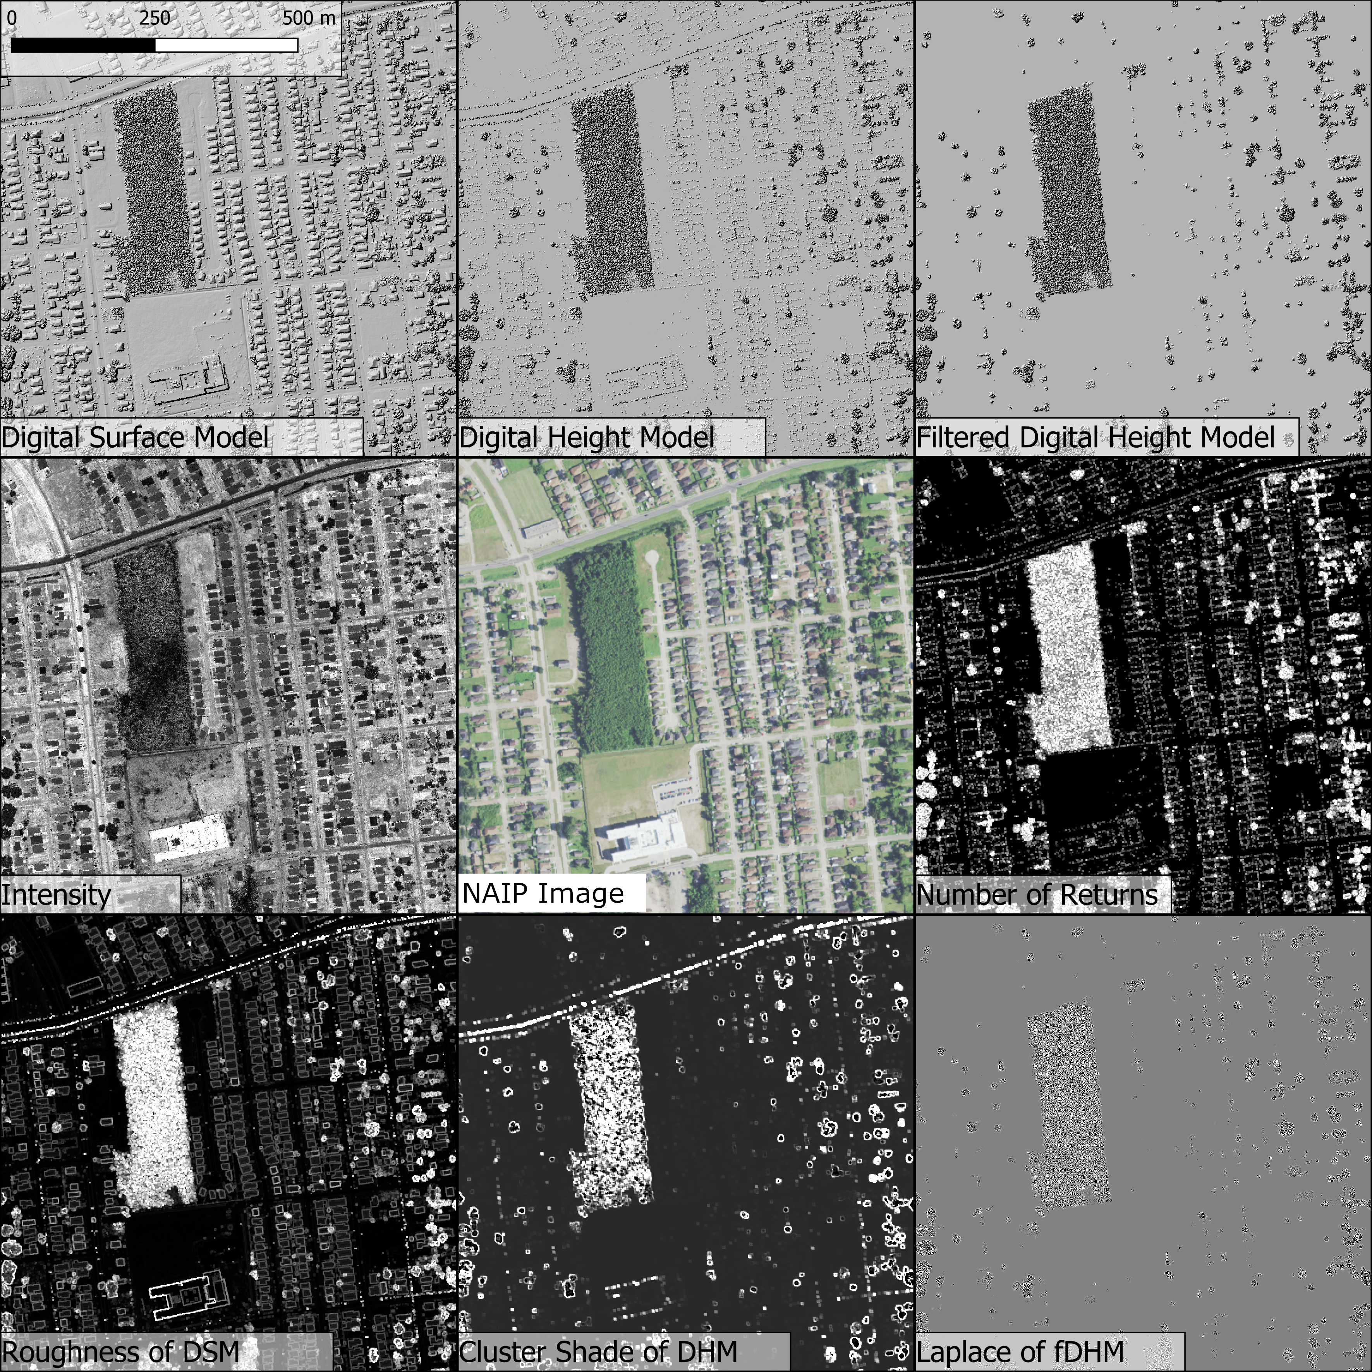

Figure . Representations of selected raster grids derived from LiDAR for a portion of the study area in watershed 080902030201 (New Orleans, LA). Note that the elevation-based rasters are displayed as hillshades.



Figure . Distribution of watersheds analyzed in this study, with 12-digit USGS hydrologic unit code given.



Figure . Decision tree of the final model. fidhr = filtered digital height model roughness. dsmro = digital surface model roughness. dsmlp = Laplace filter of digital surface model. demsl = slope of digital elevation model. dsmsl = slope of digital surface model.

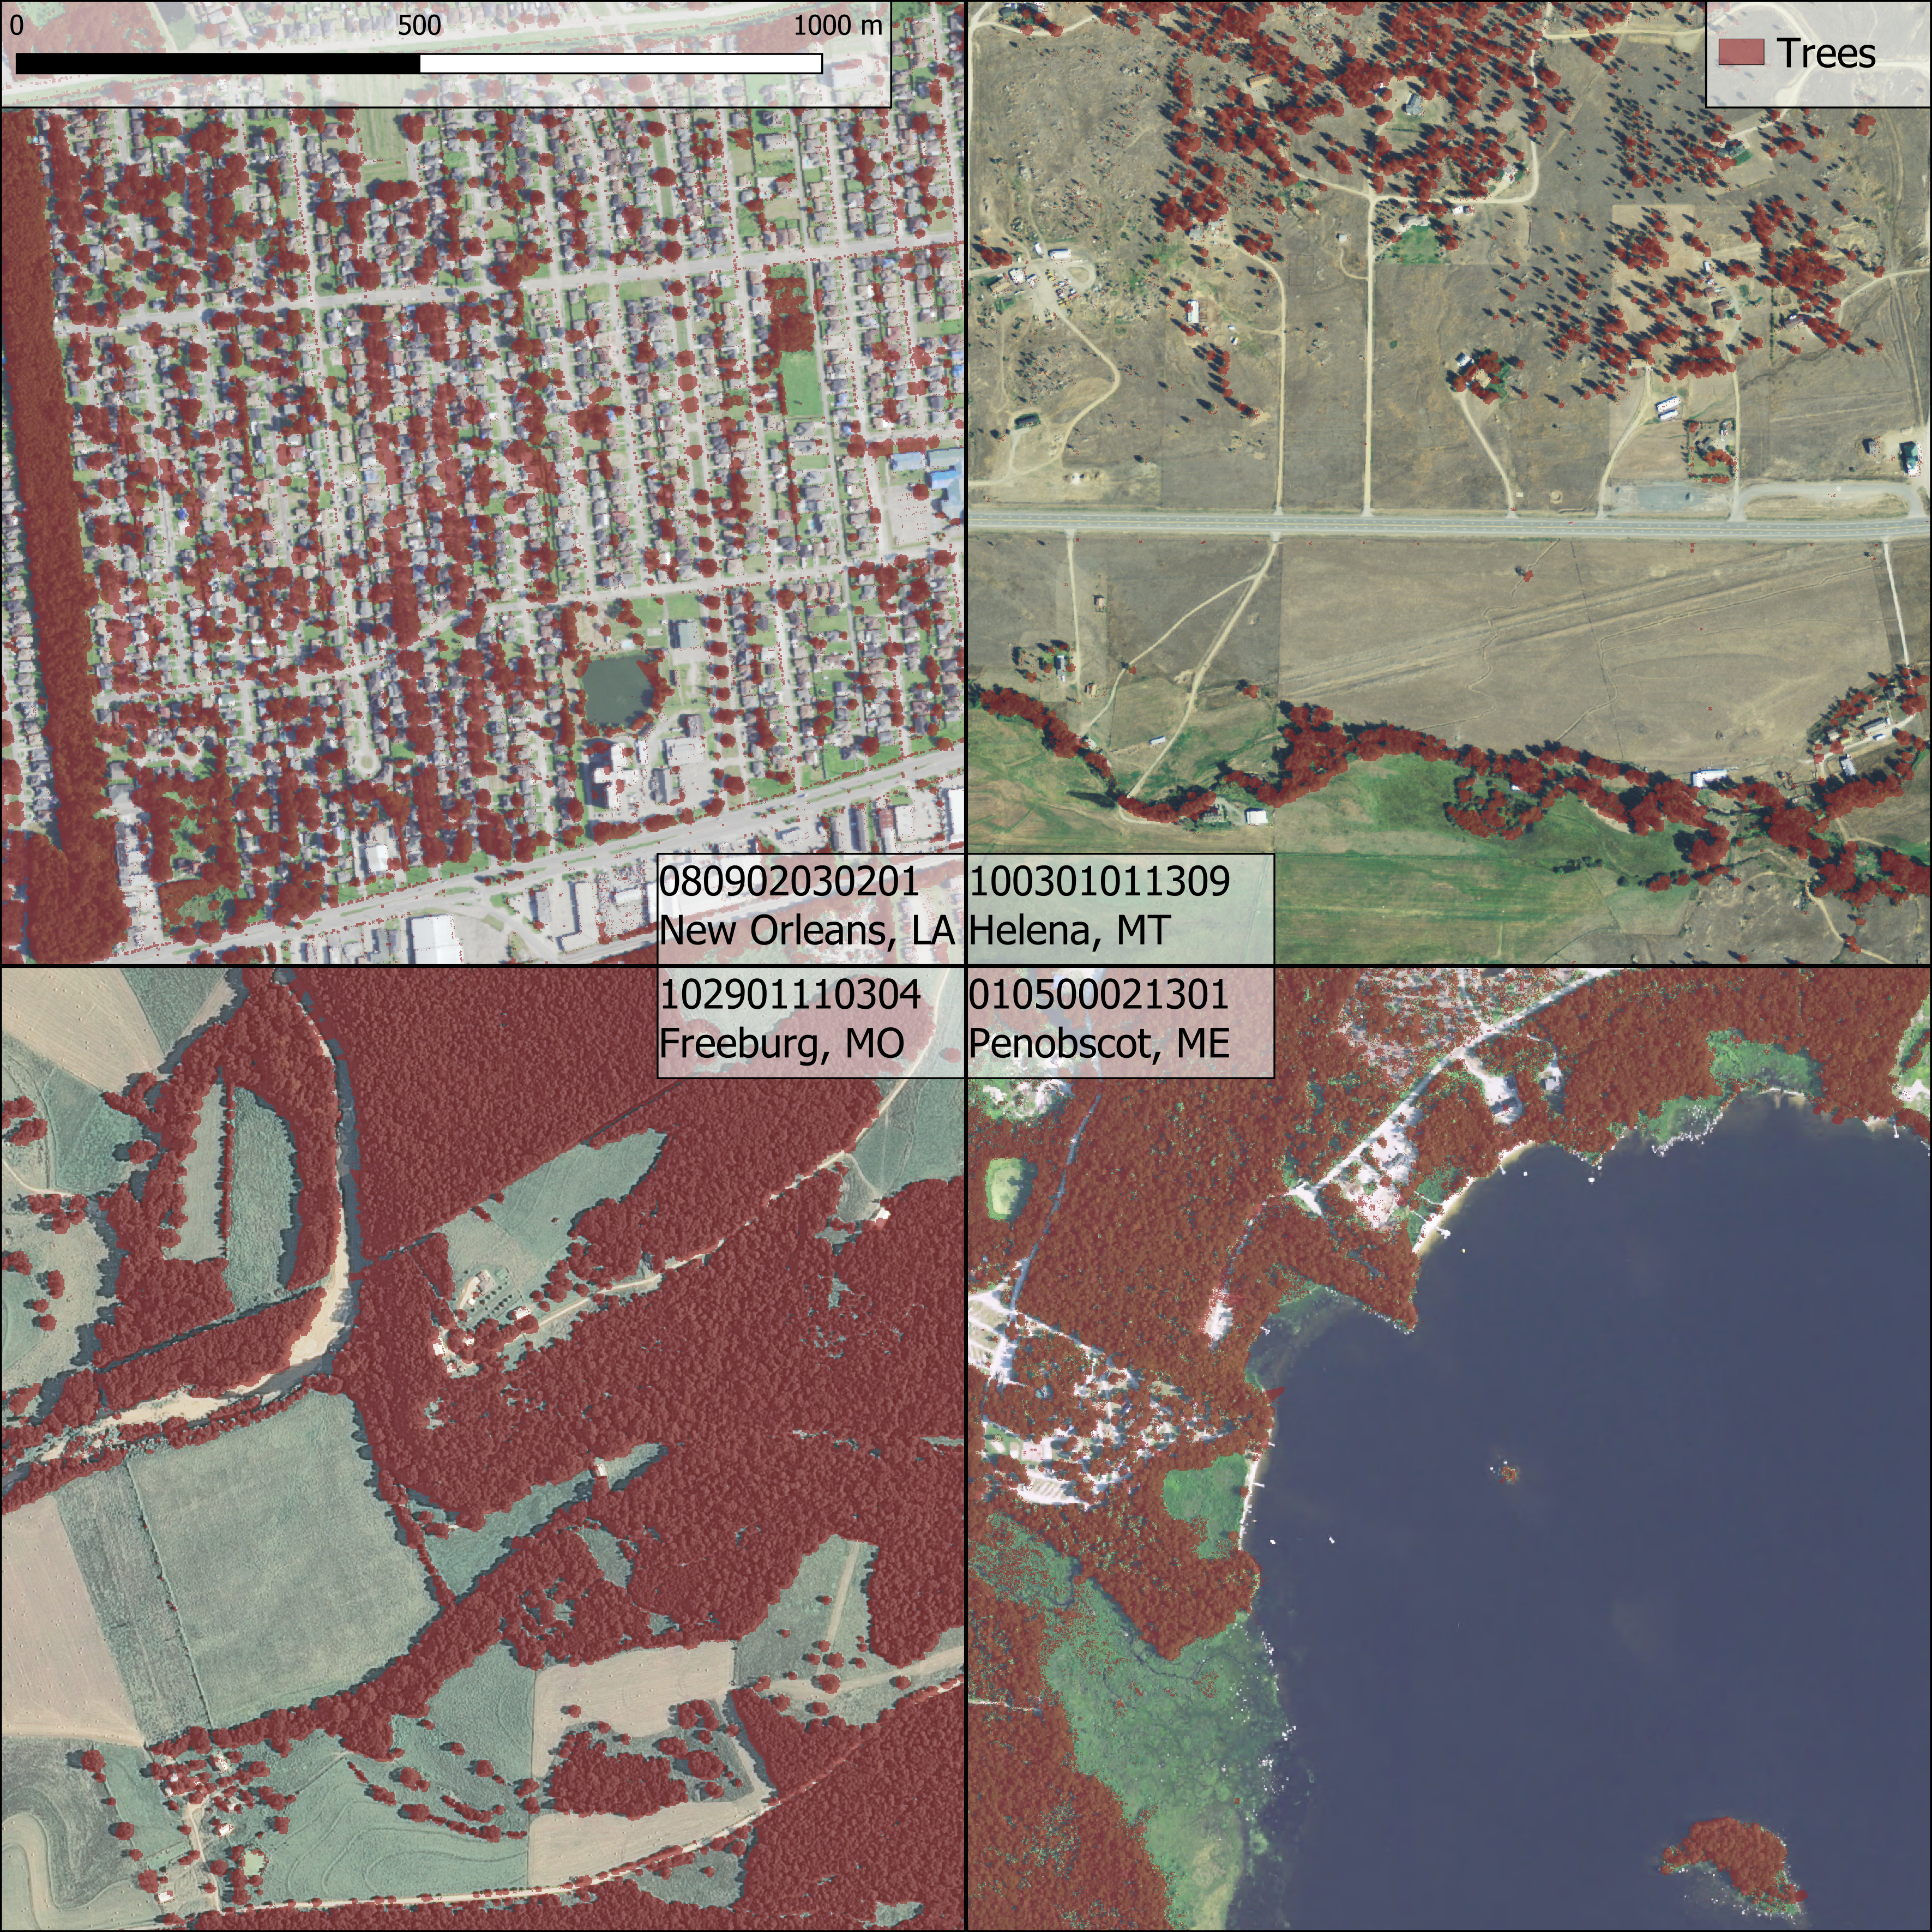

Figure . Sample classifications for the three of the testing study areas (080902030201, 100301011309, 102901110304) and one training study area (010500021301). Note that the orthoimagery for the New Orleans watershed is not perfectly contemporaneous with the LiDAR input, and so some trees in the study area were removed between LiDAR and orthoimagery data collection. It is notable that of the three testing watersheds, New Orleans shows the greatest density of false positives as result of the high number of building edges and powerlines that filtering of the DHM did not remove.

# Acknowledgements

We give our thanks to Connor Reed for his assistance with the creation of our manually classified land cover dataset.

# Funding

This work was partially supported by the Natural Resources Conservation Service (Agreement number NR194741XXXXC005).

# References

|  |  |
| --- | --- |
| [1] | J. W. Coulston, G. G. Moisen, B. T. Wilson, M. V. Finco, W. B. Cohen and C. Brewer, "Modeling Percent Tree Canopy Cover: A Pilot Study," *Photogrammetric Engineering & Remote Sensing,* pp. 715-727, 2012. |
| [2] | G. M. Foody, "Status of land cover classification accuracy assessment," *Remote Sensing of Environment,* vol. 80, no. 1, pp. 185-201, 2002. |
| [3] | L. Ma, M. Li, X. Ma, L. Cheng, P. Du and Y. Liu, "A review of supervised object-based land-cover image classification," *ISPRS Journal of Photogrammetry and Remote Sensing,* vol. 130, pp. 277-293, 2017. |
| [4] | J. P. O'Neil-Dunne, S. W. MacFaden, A. R. Royar and K. C. Pelletier, "An object-based system for LiDAR data fusion and feature extraction," *Geocarto International,* vol. 28, no. 3, pp. 227-242, 2013. |
| [5] | R. O. Dubayah and J. B. Drake, "Lidar Remote Sensing for Forestry," *Journal of Forestry,* vol. 98, no. 6, pp. 44-46, 2000. |
| [6] | N. R. Goodwin, N. Coops, A. Christen and J. A. Voogt, "Characterizing urban surface cover and structure with airborne lidar technology," *Canadian Journal of Remote Sensing,* vol. 35, no. 3, pp. 297-309, 2009. |
| [7] | S. W. MacFaden, J. W. Lu and A. Rundle, "High-resolution tree canopy mapping for New York City using LIDAR and object-based image analysis," *Journal of Applied Remote Sensing,* vol. 6, no. 1, p. 3567, 2012. |
| [8] | J. Holmgren and E. Lindberg, "Tree crown segmentation based on a tree crown density model derived from Airborne Laser Scanning," *Remote Sensing Letters,* vol. 10, no. 12, pp. 1143-1152, 2019. |
| [9] | Z. Zhen, L. J. Quackenbush and L. Zhang, "Trends in Automatic Individual Tree Crown Detection and Delineation—Evolution of LiDAR Data," *Remote Sensing,* vol. 8, no. 4, p. 333, 2016. |
| [10] | J. Heinzel and B. Koch, "Exploring full-waveform LiDAR parameters for tree species classification," *International Journal of Applied Earth Observation and Geoinformation,* vol. 13, no. 1, pp. 152-160, 2011. |
| [11] | J. Zhang and X. Lin, "Advances in fusion of optical imagery and LiDAR point cloud applied to photogrammetry and remote sensing," *International Journal of Image and Datae Fusion,* vol. 8, no. 1, pp. 1-31, 2017. |
| [12] | M. J. Garcia-Quijano, J. R. Jensen, M. Hodgson and B. C. Hadley, "Significance of Altitude and Posting Density on Lidar-derived Elevation Accuracy on Hazardous Waste Sites," *Photogrammetric Engineering and Remote Sensing,* Vols. 1137-1146, pp. 1137-1146, 2008. |
| [13] | R. Kimmel and A. Bruckstein, "Regularized Laplacian Zero Crossings as Optimal Edge Integrators," *International Journal of COmputer Vision,* vol. 53, no. 3, pp. 225-243, 2003. |
| [14] | R. M. Haralick, K. Shanmugam and I. Dinstein, "Textural features for image classification," *IEEE Transactions on Systems, Man and Cybernetics,* Vols. SMC-3, no. 6, pp. 610-621, 1973. |

1. Responsible for design, implementation and testing of model, collection and processing of data, and drafting of manuscript.
2. Responsible for supervision of model design, manuscript drafting and revision.